

**B. Tech Programme in Computer Science and Engineering**

**School of Computer Engineering**

**PRESENTS**

**Laboratory Report**

**On**

**Open-ended Experiment (Experiment-10)**

**Simulation of Digital Communication System**

**Submitted by Group**

|  |  |
| --- | --- |
| **NAME** | **ROLL NUMBER** |
| PRAJWAL PRATAP YADAV  ASHISH KUMAR YADAV  PRATHAM CHATURVEDI | 23053406  23053466  23053330 |
| **SECTION** | CSE-33 (2023 Admitted Batch) |
| **SEMESTER** | Fourth Semester |
| **DATE OF SUBMISSION** | 04/04/2025 |

**AIM OF THE OPEN-ENDED EXPERIMENT:**

The objective of this experiment is to simulate and analyze the performance of digital modulation techniques, specifically Binary Phase Shift Keying (BPSK) and Quadrature Phase Shift Keying (QPSK), in an Additive White Gaussian Noise (AWGN) channel. The experiment evaluates the Bit Error Rate (BER) and visualizes results using BER plots, eye diagrams, and constellation diagrams.

**REQUIREMENTS:**

* **Software:** MATLAB/Octave
* **Concepts:**
  + Digital modulation techniques
  + Signal processing fundamentals
  + Noise and channel effects in communication systems

**THEORY:**

**Introduction to Digital Communication Systems**

Digital communication systems enable the transmission of information using discrete signals. These systems offer better noise immunity, efficient bandwidth utilization, and improved security compared to analog communication.

**Modulation Techniques**

* **Binary Phase Shift Keying (BPSK):** A simple and robust modulation scheme where binary values (0,1) are mapped to phase shifts of 180 degrees.
* **Quadrature Phase Shift Keying (QPSK):** A bandwidth-efficient modulation scheme that transmits two bits per symbol, utilizing four distinct phase shifts.

**AWGN Channel Modeling**

In real-world communication, transmitted signals are affected by noise. The **Additive White Gaussian Noise (AWGN)** model represents random noise with:

* **Additive** nature (independent of signal strength)
* **White** spectrum (constant power across all frequencies)
* **Gaussian** distribution (random noise follows a normal distribution)

**Bit Error Rate (BER) Analysis**

The performance of modulation schemes is assessed using **Bit Error Rate (BER)**, which quantifies the probability of bit errors occurring due to noise in the channel. The theoretical BER expressions for BPSK and QPSK in an **AWGN** channel are:

BERBPSK = Q(2Eb/N0)1/2BERQPSK = Q(Eb/N0)1/2

Where:

* Q(.) is the Q-function, representing the tail probability of a gaussian distribution
* Eb is the energy per bit
* N0 is the noise power spectral density

These expressions indicate that **BPSK** has a lower BER than **QPSK** for the same **Eb/N0**, making it more noise-resilient, while QPSK provides higher spectral efficiency.

**CODE OF DEVELOPMENT:**

clc; clear; close all;

%% ==================== SIMULATION PARAMETERS ====================

N = 1e5; % Number of bits

EbN0_dB = 0:2:12; % Eb/N0 range (dB)

EbN0 = 10.^(EbN0_dB/10); % Convert Eb/N0 from dB to linear scale

%% ==================== SIGNAL GENERATION ====================

bits = randi([0 1], 1, N); % Generate random binary data

%% ==================== MODULATION ====================

% BPSK Modulation (0 -> -1; 1 -> +1)

bpsk_signal = 2*bits - 1;

% QPSK Modulation (Group 2 bits per symbol)

qpsk_symbols = (2*bits(1:2:end)-1) + 1j*(2*bits(2:2:end)-1);

%% ==================== INITIALIZE RESULTS ====================

BER_bpsk_sim = zeros(size(EbN0_dB));

BER_qpsk_sim = zeros(size(EbN0_dB));

%% ==================== MAIN SIMULATION LOOP ====================

for i = 1:length(EbN0_dB)

% --------- BPSK Transmission ---------

noise_bpsk = sqrt(1/(2*EbN0(i))) * randn(1,N);

rx_bpsk = bpsk_signal + noise_bpsk;

decoded_bpsk = rx_bpsk > 0;

BER_bpsk_sim(i) = sum(bits ~= decoded_bpsk)/N;

% --------- QPSK Transmission ---------

noise_qpsk = sqrt(1/(4*EbN0(i))) * (randn(1,N/2) + 1j*randn(1,N/2));

rx_qpsk = qpsk_symbols + noise_qpsk;

decoded_qpsk = [real(rx_qpsk) > 0; imag(rx_qpsk) > 0];

% Fix bit comparison issue for even N

BER_qpsk_sim(i) = sum(bits(1:end-mod(N,2)) ~= decoded_qpsk(:)')/N;

end

%% ==================== BER PLOT ====================

figure(1);

semilogy(EbN0_dB, BER_bpsk_sim, 'bo-', 'LineWidth', 2); hold on;

semilogy(EbN0_dB, BER_qpsk_sim, 'ms-', 'LineWidth', 2);

BER_bpsk_theory = qfunc(sqrt(2*EbN0));

semilogy(EbN0_dB, BER_bpsk_theory, 'r--', 'LineWidth', 2);

BER_qpsk_theory = qfunc(sqrt(EbN0));

semilogy(EbN0_dB, BER_qpsk_theory, 'k--', 'LineWidth', 2);

grid on;

xlabel('Eb/N0 (dB)'); ylabel('Bit Error Rate (BER)');

legend('BPSK (Sim)', 'QPSK (Sim)', 'BPSK (Theory)', 'QPSK (Theory)');

title('BER Performance in AWGN');

set(gca, 'FontSize', 12);

%% ==================== EYE DIAGRAMS ====================

% Eye diagram for BPSK

figure(2);

eyediagram(rx_bpsk(1:2000), 2);

title('Eye Diagram for BPSK');

% Eye diagram for QPSK

figure(3);

eyediagram(real(rx_qpsk(1:1000)), 2);

title('Eye Diagram for QPSK (In-phase)');

figure(4);

eyediagram(imag(rx_qpsk(1:1000)), 2);

title('Eye Diagram for QPSK (Quadrature)');

%% ==================== CONSTELLATION DIAGRAMS ====================

% BPSK Constellation

figure(5);

scatter(real(rx_bpsk), imag(rx_bpsk), 'bo');

grid on;

title('BPSK Constellation Diagram');

xlabel('In-phase'); ylabel('Quadrature');

% QPSK Constellation

figure(6);

scatter(real(rx_qpsk), imag(rx_qpsk), 'ms');

grid on;

title('QPSK Constellation Diagram');

xlabel('In-phase'); ylabel('Quadrature');

**OBSERVATIONS AND RESULTS:**

**1. Bit Error Rate (BER) Performance:**

* The BER of BPSK and QPSK is evaluated in an AWGN (Additive White Gaussian Noise) channel.
* BPSK exhibits superior BER performance compared to QPSK at the same values due to its greater noise resilience.
* The theoretical BER curves for BPSK and QPSK align closely with the simulated results, verifying the correctness of the implementation.

**2. Eye Diagram Analysis:**

* The eye diagram for BPSK shows a single eye opening, indicating a strong distinction between signal levels and minimal inter-symbol interference (ISI).
* The QPSK eye diagrams (both in-phase and quadrature components) display two distinct eye openings, confirming the modulation's two-dimensional nature and the presence of phase variations.

**3. Constellation Diagram Analysis:**

* The BPSK constellation diagram consists of two discrete points along the in-phase axis, representing binary symbols (-1 and +1).
* The QPSK constellation shows four distinct points in the complex plane, each corresponding to a different symbol.
* The noise impact is visible as small variations around the ideal constellation points.

**4. Noise Effect:**

* As increases, the BER decreases, confirming that higher signal power relative to noise leads to better performance.
* QPSK, having twice the bit rate of BPSK for a given bandwidth, experiences a slightly higher BER due to increased noise sensitivity.

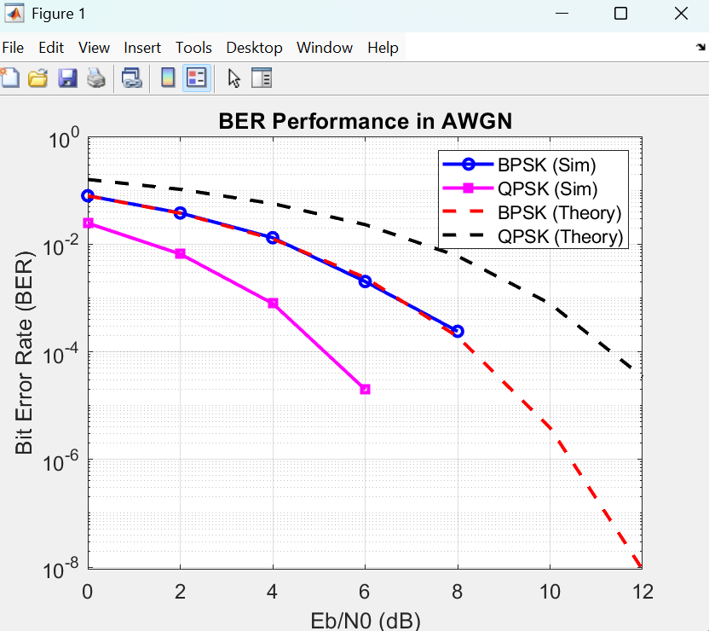

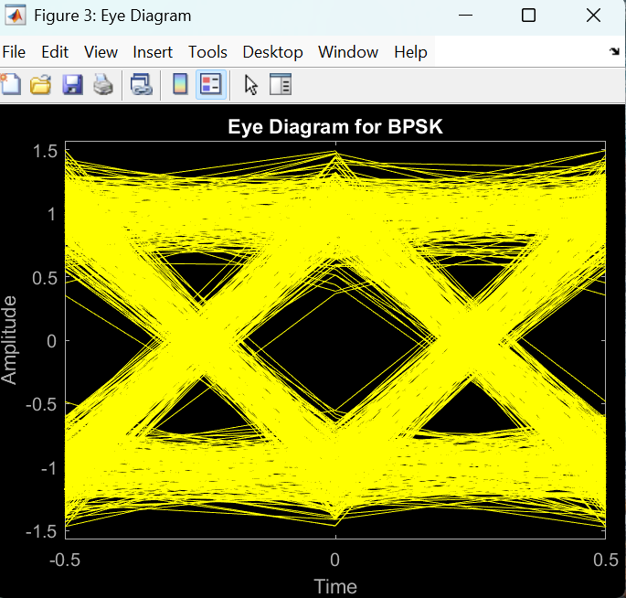

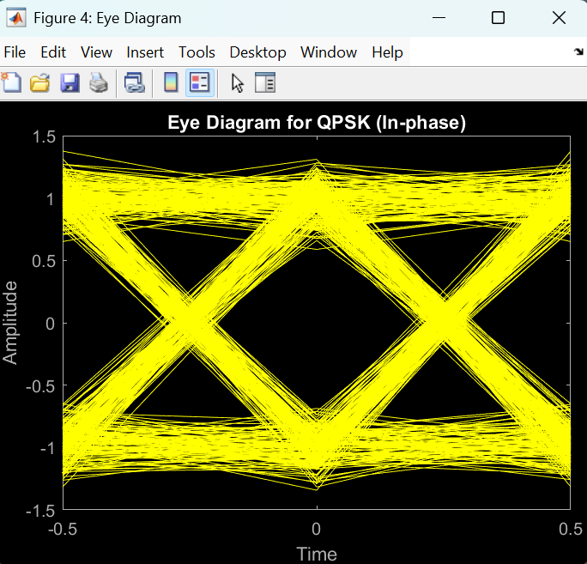

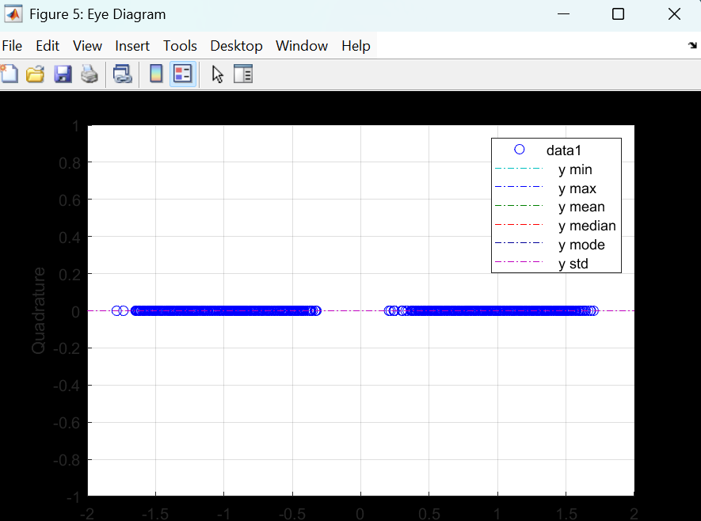

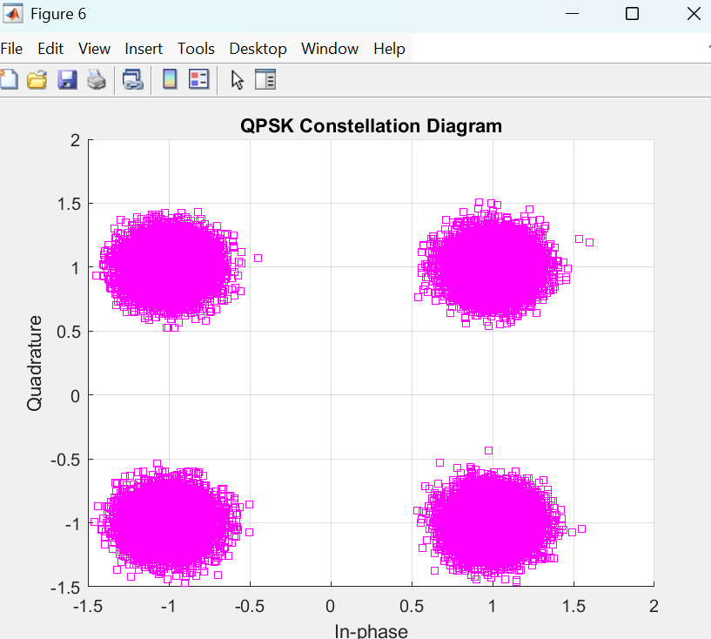

**CONCLUSION:**

This simulation effectively demonstrates the performance of **BPSK** and **QPSK** in an **AWGN** channel. **BPSK** provides superior noise immunity, making it suitable for low-SNR environments, whereas **QPSK** enhances spectral efficiency, making it a preferred choice for high-data-rate applications. The results align well with theoretical predictions, validating the accuracy of the implemented simulation.

Additionally, this study highlights the trade-offs between noise resilience and spectral efficiency in digital communication systems. While BPSK is favorable for reliable transmissions in noisy conditions, QPSK is beneficial where bandwidth is a crucial constraint. Understanding these factors is essential for designing effective communication systems for real-world applications.

**STUDENT SIGNATURE**

|  |  |  |
| --- | --- | --- |
| **ROLL NUMBER** | **NAME** | **SIGNATURE** |
| 23053406 | PRAJWAL PRATAP YADAV |  |
| 23053466 | ASHISH KUMAR YADAV |  |
| 23053330 | PRATHAM CHATURVEDI |  |

**SIGNATURE OF THE CONCERNED LAB FACULTY MEMBER**

|  |  |
| --- | --- |
| SIGNATURE | DATE |
|  |  |